

IPGard Secure KVM Administration and Security Management Tool Guide   
(KVM)

DESIGNED AND MADE IN USA

Release Date: June 8th, 2020

Document ID: ADG-0S0-ALL

Version: 4.1

Prepared By: Albert Cohen

Prepared For: IPGard

Table of Contents

Table of Contents 2

1. Overview 4

2. Intended Audience 5

3. System Requirements 6

4. System Setup 7

5. Initiate Session 8

6. User Functions 9

6.1. User – Log-in 9

6.2. User – CAC Port Configuration 9

6.3. User – View Registered CAC Peripheral 10

6.4. User – Terminate Session 10

7 Administrator Functions 12

7.1 Administrator – Log-in 12

7.2 Administrator – CAC Port Configuration 12

7.3 Administrator – View Registered CAC Peripheral 13

7.4 Administrator – Change User Credentials 13

7.5 Administrator – Change Administrator Credentials 14

7.6 Administrator – Event Log (auditing) 14

7.7 Administrator – Restore Factory Defaults 16

7.8 Administrator – Terminate Session 16

**Table of Figures**

Figure 1: Administration and Security Management Tool 7

Figure 2: Initiate Session Capture 8

Figure 3: User Log-in 9

Figure 4: User CAC Port Registration 10

Figure 5: User View Registered CAC Peripheral 10

Figure 6: Terminate Session 11

Figure 7: Administrator Log-in 12

Figure 8: Admin CAC Port Registration 13

Figure 9: Admin View Registered CAC Peripheral 13

Figure 10: Admin Change User Credentials 14

Figure 11: Admin Change Admin Credentials 14

Figure 12: Sample Log 15

Figure 13: Event Codes 16

Figure 14: Restore Factory Defaults 16

**List of Tables**

Table 1: User/Administrator Function Permissions 4

Table 2: Peripheral Devices supported by the KVM TOE 6

1. Overview

The Administration and Security Management Tool was designed by IPGARD to allow identified and authenticated users and system administrators to perform the following management activities on IPGARD Secure KVM switch devices:

|  |  |  |
| --- | --- | --- |
| Menu Function | User | Administrator |
| Log-in | ✓ | ✓ |
| Change User Access Credentials |  | ✓ |
| Change Admin Access Credentials |  | ✓ |
| View Registered CAC Device* | ✓ | ✓ |
| Register New CAC Device* | ✓ | ✓ |
| Auditing - Dump Log |  | ✓ |
| Restore Factory Default (reset) |  | ✓ |
| Terminate Session | ✓ | ✓ |

Table 1: User/Administrator Function Permissions

*for models that support USB authentication devices only (-P in model name)

An authenticated User and authenticated Administrator are both considered types of administrators for the purposes of compliance with version 3.0 of the Protection Profile (PP) for Peripheral Sharing Switch (PSS), to which this product claims conformance.

This guide outlines the required information to operate each function in the above table.

1. Intended Audience

The information in this document is for authorized system administrators or users. If the product does not behave in the manner specified by this document, please contact IPGARD technical support at [support@IPGARD.com](mailto:support@IPGARD.com).

1. System Requirements

* The IPGARD Secure KVM switch is compatible with standard personal/portable computers, servers or thin-clients, running operating systems such as Windows or Linux.

The Administration and Security Management Tool can only run on Windows. The supported versions are Windows XP, 7, 8, and 10. Version 2.0 or later of the .NET framework is also required.

* The peripheral devices that supported by the KVM TOE are listed in the following table:

|  |  |
| --- | --- |
| Console Port | Authorized Devices |
| Keyboard | Wired keyboard and keypad without internal USB hub or composite device functions, unless the connected device has at least one endpoint which is a keyboard or mouse HID class, KVM extender. |
| Display | Display, Projector, Video or KVM extender. |
| Audio out | Analog amplified speakers, Analog headphones, Digital audio appliance. |
| Mouse / Pointing Device | Any wired mouse or trackball without internal USB hub or composite device functions, Touch-screen, Multi-touch or digitizer, KVM extender. |
| User Authentication Device | Smart-card reader, PIV/CAC reader, Token or Biometric reader.* |

Table 2: Peripheral Devices supported by the KVM TOE

*TOE -P models only

1. System Setup

Note: Only one computer connected to the KVM port 1 is required for any activity in this guide.

* Ensure that device power is turned off or disconnected from the unit and the computer.
* Using USB cable Type-A to Type-B connect the PC to the device host K/M port 1. Connect a second USB cable Type-A to Type-B between the PC and the KVM if CAC port configuration is also required.
* Connect a USB keyboard and mouse in the two USB console ports.
* Connect the appropriate video cable between the PC and the KVM video 1 port.
* Connect the monitor to the KVM console video output connector.
* Power up the PC and the device.
* Download the Administration and Security Management Tool from the following link to the PC - <http://ipgard.com/tools-software/>
* Run the Administration and Security Management Tool executable file. Figure 1 below is a screenshot of the tool you should be seeing on your screen.

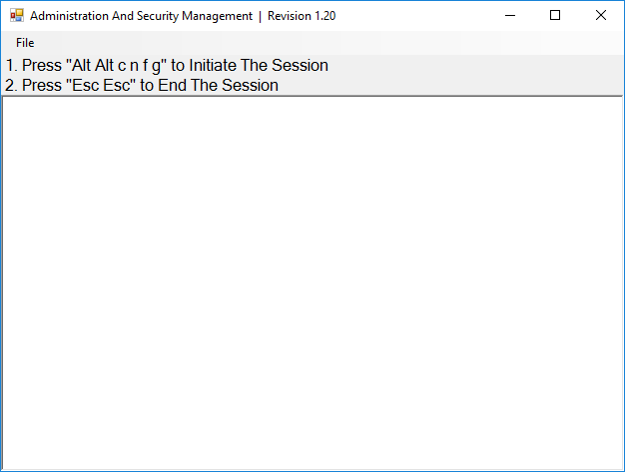

Figure 1: Administration and Security Management Tool

1. Initiate Session

* Using the keyboard, press “Alt Alt cnfg”
* At this stage the mouse connected to the device will stop functioning.
* Figure 2 below is a screenshot of the tool you should be seeing on your screen.

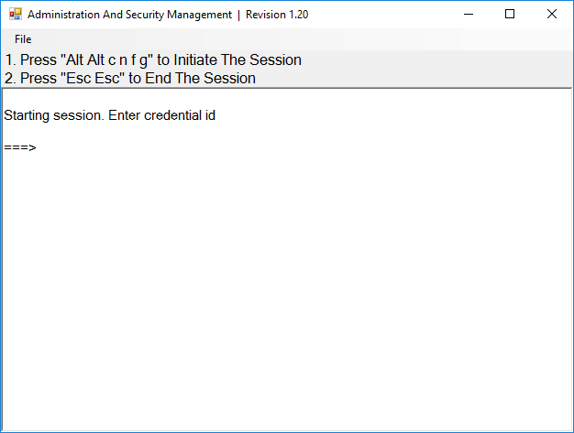

Figure 2: Initiate Session Capture

1. User Functions

## User – Log-in

* Enter the default username “user” and press Enter.
* Enter the default password “12345” and press Enter.
* Figure 3 below is a screenshot of the tool you should be seeing on your screen.

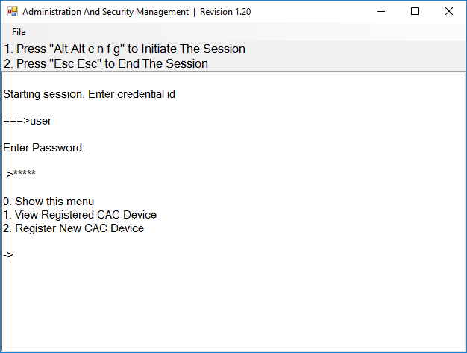

Figure 3: User Log-in

## User – CAC Port Configuration

CAC (Common Access Card) port configuration is an optional feature, allowing registration of any specific USB peripheral to operate with the device. Only one peripheral can be registered at a time and only the registered peripheral will operate with the device. By default, when no peripheral is registered, the device will operate with any Smart Card Reader.

* Select option 2 from the menu on your screen and press Enter.
* Connect the peripheral device to be registered to the CAC USB port in the console side of the device and wait until the device is reading the new peripheral information.
* The device will list the information of the connected peripheral on the screen and buzz 3 times when registration is completed.
* Figure 4 below is a screenshot of the tool you should be seeing on your screen. A USB Smart Card Reader was registered to the CAC port in this example:

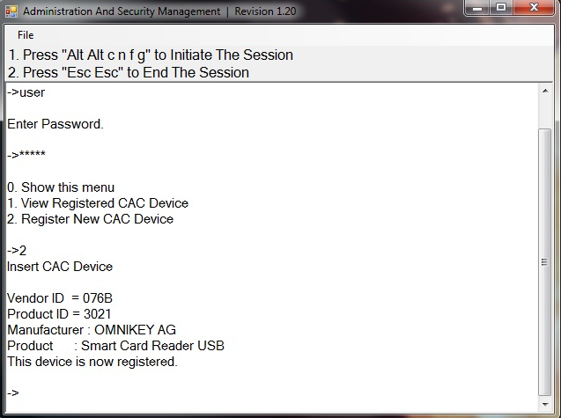

Figure 4: User CAC Port Registration

## User – View Registered CAC Peripheral

* Select option 1 from the menu on your screen and press Enter.
* Figure 5 below is a screenshot of the tool you should be seeing on your screen. A USB Smart Card Reader is registered to the CAC port in this example:

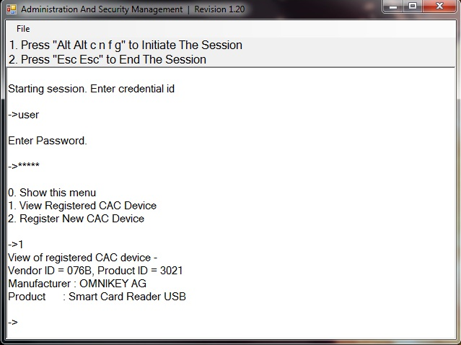

Figure 5: User View Registered CAC Peripheral

## User – Terminate Session

* Press “Esc Esc”.
* Figure 6 below is a screenshot of the tool you should be seeing on your screen.

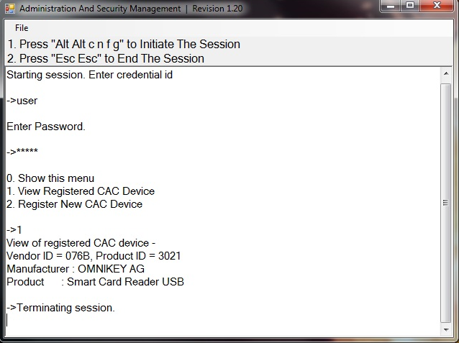

Figure 6: Terminate Session

# Administrator Functions

## Administrator – Log-in

* Enter the default username “admin” and press Enter.
* Enter the default password “12345” and press Enter.
* Figure 7 below is a screenshot of the tool you should be seeing on your screen.

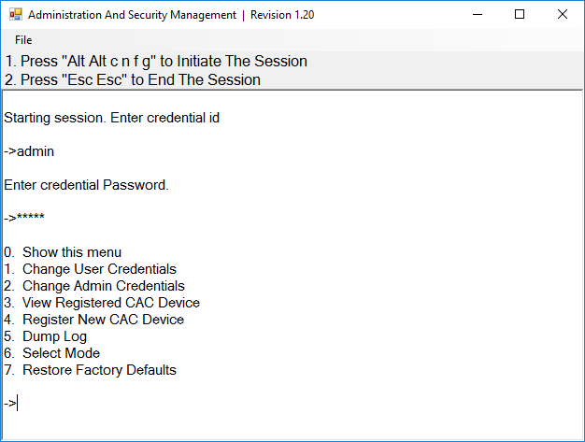

Figure 7: Administrator Log-in

## Administrator – CAC Port Configuration

CAC (Common Access Card) port configuration is an optional feature, allowing registration of any specific USB peripheral to operate with the device. Only one peripheral can be registered at a time and only the registered peripheral will operate with the device. By default, when no peripheral is registered, the device will operate with any Smart Card Reader.

* Select option 4 from the menu on your screen and press Enter.
* Connect the peripheral device to be registered to the CAC USB port in the console side of the device and wait until the device is reading the new peripheral information.
* The device will list the information of the connected peripheral on the screen and buzz 3 times when registration is completed.
* Figure 8 below is a screenshot of the tool you should be seeing on your screen. A USB Smart Card Reader was registered to the CAC port in this example:

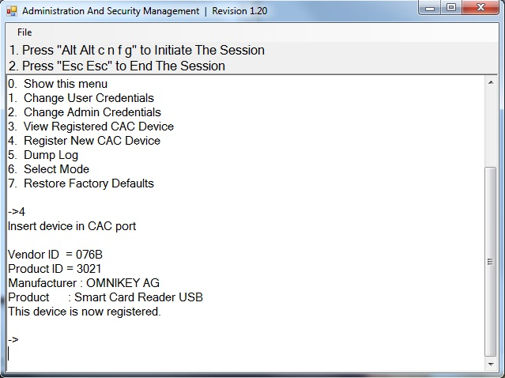

Figure 8: Admin CAC Port Registration

## Administrator – View Registered CAC Peripheral

* Select option 3 from the menu on your screen and press Enter.
* Figure 9 below is a screenshot of the tool you should be seeing on your screen. A USB Smart Card Reader is registered to the CAC port in this example:

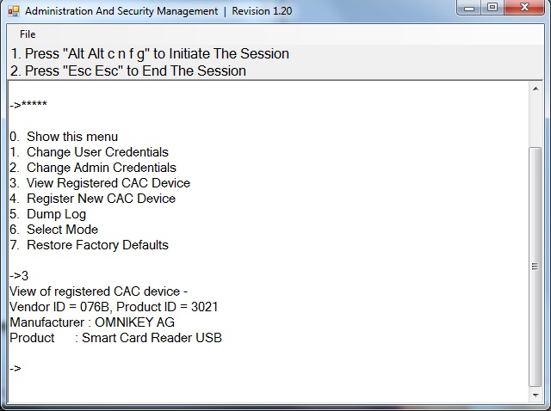

Figure 9: Admin View Registered CAC Peripheral

## Administrator – Change User Credentials

* Select option 1 from the menu on your screen and press Enter.
* Enter the new User ID and press Enter.
* Enter the new User ID again and press Enter.
* Enter the new User password and press Enter.
* Enter the new User password again and press Enter.
* Figure 10 below is a screenshot of the tool you should be seeing on your screen.

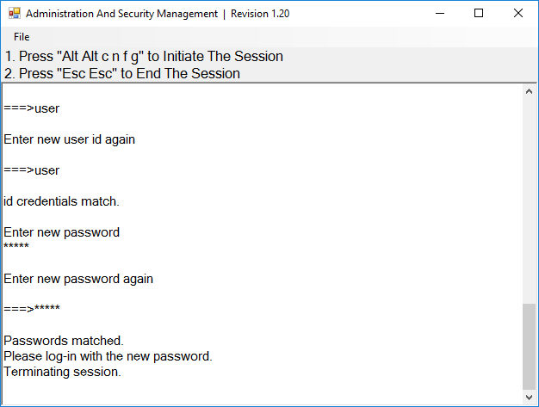

Figure 10: Admin Change User Credentials

## Administrator – Change Administrator Credentials

* Select option 2 from the menu on your screen and press Enter.
* Enter the new Administrator ID and press Enter.
* Enter the new Administrator ID again and press Enter.
* Enter the new Administrator password and press Enter.
* Enter the new Administrator again and press Enter.
* Figure 11 below is a screenshot of the tool you should be seeing on your screen.

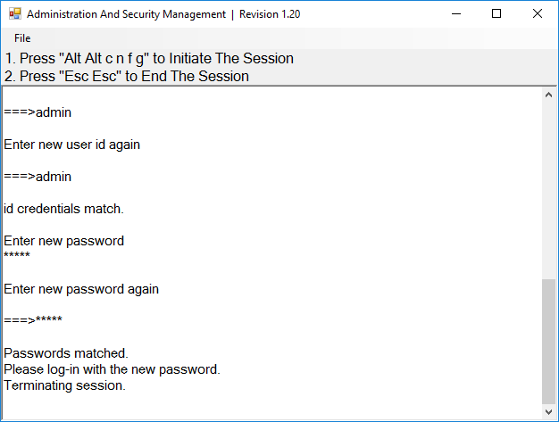

Figure 11: Admin Change Admin Credentials

## Administrator – Event Log (auditing)

Event Log is a detailed report of critical activities stored in the device memory. The following steps provide instructions for dumping the log by identified and authenticated administrator.

* Select option 5 from the menu on your screen and press Enter.
* The last 10 events will be presented in the log as shown in Figure 12 below: 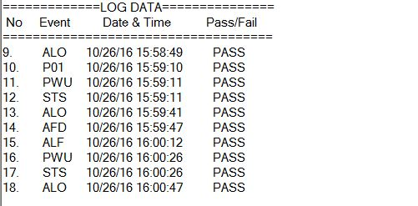

Figure 12: Sample Log

* Press the Enter key to see the previous 10 events. This can be repeated for up to the most recent 100 events.
* The Log header includes the following information:
* Unit’s Model
* Unit’s S/N
* Anti-tamper switch status
* Manufacturing Site
* Manufacturing Date
* Anti-tamper Arming Date
* Number of current records in the Log
* The log data may include events with any of the codes shown in Figure 13 below:

|  |  |  |
| --- | --- | --- |
| # | Code | Description |
| 1 | ALO | Administrator Log On |
| 2 | ALF | Administrator Log Off |
| 3 | APU | Administrator Permissions Update |
| 4 | ARM | Arming A/T System |
| 5 | CAC | CAC Configuration |
| 6 | EDL | N/A |
| 7 | LGD | LOG Dump |
| 8 | PWU | Power Up |
| 9 | RCA | Rejected CAC Device |
| 10 | AFD | Restore Factory Default |
| 11 | RKM | Rejected Keyboard or Mouse |
| 12 | STS | Self-Test |
| 13 | TMP | Device Tampered, Review by MFR only |
| 14 | ULO | User Log On |
| 15 | ULF | User Log Off |
| 16 | UPU | User Permissions Update |

Figure 13: Event Codes

## Administrator – Restore Factory Defaults

* Select option 7 from the menu on your screen and press enter.
* The following menu will be presented (see Figure 14 below):

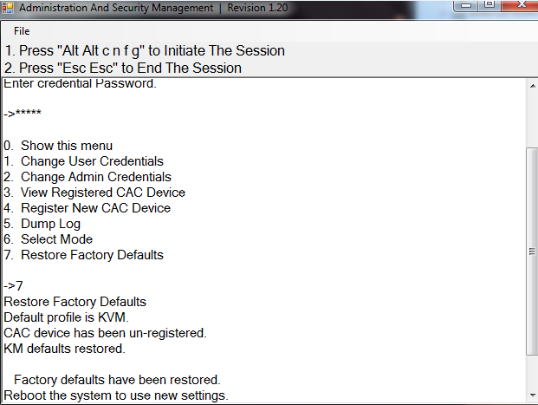

Figure 14: Restore Factory Defaults

The unit will perform power reset automatically. All system defaults will be restored and any registered CAC devices will be cleared.

## Administrator – Terminate Session

Press “Esc Esc”.